BAROKAH MAPAN JAYA
Connecting the Archipelago, Advancing the Nation

PROSEDUR KENDALI DOKUMEN | BMJ-05.03
SURAT PERMINTAAN BARANG | HO/SH | THN

Nama Kapal : KM.L MALAHAYATI
Tanggal : 23 Juni,2026
Bagian : Mesin

NO. | NAMA BARANG | QTY | HARGA | TGL/TERAKIR RENEW | KETERANGAN | SUPPLY | FOTO
1 | FILTER OLI M/E (DONALDSON J86-10480) | 4 Pcs |  | 23 April,2026 |  |  | 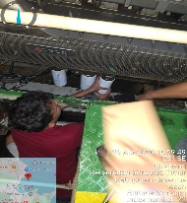
2 | BY PASS OLI M/E (DONALDSON P55077) | 4 Pcs |  | 23 April,2026 |  |  | 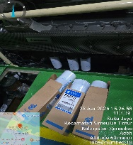
3 | FILTER OLI A/E (DONALDSON J86-88008) | 6 Pcs |  | 23 April,2026 |  |  | 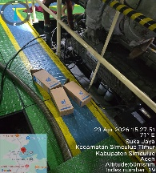
4 | BY PASS OLI A/E (DONALDSON J86-10800) | 6 Pcs |  | 23 April,2026 |  |  | 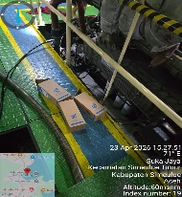
5 | OLI SAE 40 | 3 Drum |  | 23 April,2026 |  |  | 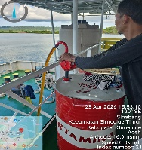
6 | SENTER | 2 Pcs

Mengetahui, Mengetahui, Menyetujui,

_________ _ ___________ ___________
PORT CAPT/ ENGINE LOGISTIK Manager Armada

